We love seeing you at the Grange ~
Can you help us keep it open and running?

Capital City Grange#469 was chartered in Montpelier in 1914; hence the old-fashioned name. In 1952-53 the members bought a lot in Berlin and built the hall we use today. The deed belongs to CCG#469 …as long as it is active. Since 2005, when 65 dancers joined CCG#469 to save the hall from becoming a private enterprise, the members of CCG#469 have been trying really hard to actualize the progressive agrarian values established just after the Civil War by national Patrons of Husbandry.

YOUR involvement in CCG#469 meetings, events & initiatives is what we need now!! There is plenty of room for your participation, and I hope you will join us. You can see how at the bottom of this letter.
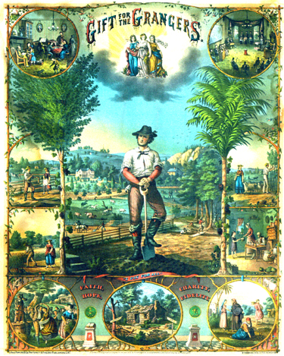

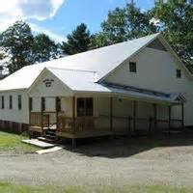

In 2019 CCG#469 will be doing KIDS TRADE & PLAY (0930-1130 on Second Saturdays) , collecting donations for Holiday Food baskets (look for donation boxes in the Hall), and the 3rd Annual Holiday Sing-Along. We will continue our Cooking Workshops in 2019 and, if we can manage it, host an Open House/ Family Fun Day or another UPSCALE/RETAIL event , or maybe a craft fair.

And we will keep our hall an affordable/accessible venue for community use.

We will continue our regular business meetings on First Saturdays, October – June starting at 4:15pm. The agenda is always in the Grange NOTES (subscribe here capitalcitygrange.org), and usually includes singing + reports on community needs & community service, health concerns, and the building itself.
This is followed at 5:30-ish by a program of public interest and, at 6-ish, with a FREE&OPEN, family-friendly potluck. EVERYONE is welcome!

Past public interest programs have included information about Central Vermont Internet, maintaining indoor air quality, health care for all and candidate forums.

And of course we have traditional things like baking contests and sing-alongs.

You can utilize your skills and develop new ones; CCG#469 needs someone to take over bookkeeping (“Treasurer”), program coordination (“Lecturer”) and building maintenance (“Hall Steward”). And you could wear a velvet sash!

We also need to wash windows, clean the fridge, mow the grass, and get rid of the birds' nests…to name a few chores.

To RENEW/RESUME your membership for 2019, just send your check ($30 made out to Capital City Grange#469) to PO Box 208, Northfield Falls, VT 05664.

If you are a NEW member, go here http://capitalcitygrange.org and complete the form at the bottom of the page on the right. Membership = only $30/calendar year .

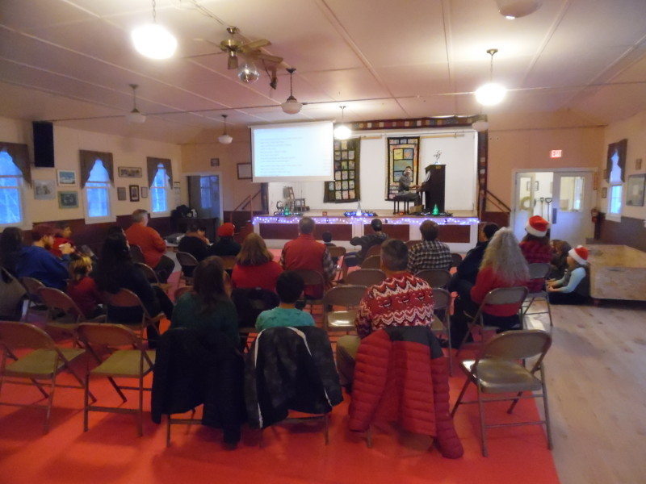

Making a “joyful noise” at the 2nd Annual Grange Holiday Sing-Along
(Additional photos of Grange events may be found in NOTES here:capitalcitygrange.org)

